BNY Capstone Proposal
Macro Surprise-Based Asset Allocation with a CIO Reasoning Agent

1. Overview

1.1 Research Question
How can macroeconomic surprises be translated into expected asset returns and tactical portfolio allocation decisions, and how does that relationship vary across financial conditions? A second objective is to test how a CIO reasoning agent can interpret model outputs to support investment decisions.
This research is built around two core hypotheses:
H1. Macroeconomic surprises contain information about future asset returns.
Markets respond not only to whether economic data are strong or weak, but to whether realized outcomes differ from market expectations.
$$\text{Macro Surprise}=\text{Actual}-\text{Consensus} \\ \text{Macro Surprise}→\text{Expected Asset Return}$$
H2. Financial conditions moderate the relationship between macro surprises and asset returns.
The same macro surprise may have different implications depending on whether financial conditions are loose or tight.

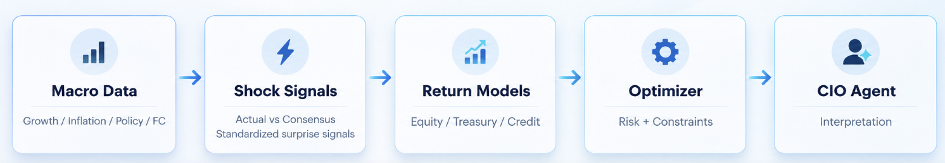
Figure 1. MVP workflow

1.2 MVP Investment Scope
Item | MVP
Macro Signals | Growth, Inflation, Policy, Financial Conditions (FC)
Assets | U.S. Equity / Treasury / IG Credit
Target | Next 1M return
Rebalancing | Monthly

2. Data

2.1 Data Collection

Use only information available at the portfolio decision date.
Group | Series | Definition | Source
Growth | NFP (Nonfarm Payrolls) | Monthly change in U.S. nonfarm employment | Bloomberg (ECO /BLS / Census / Fed / ISM)
 | Retail Sales | Monthly retail spending; proxy for consumer demand | Bloomberg (ECO /BLS / Census / Fed / ISM)
 | Industrial Production | Output of factories, mines, and utilities; production activity | Bloomberg (ECO /BLS / Census / Fed / ISM)
 | ISM Manufacturing | Survey-based manufacturing activity indicator | Bloomberg (ECO /BLS / Census / Fed / ISM)
Inflation | CPI / Core CPI | Consumer price inflation; headline and excluding food & energy | Bloomberg (ECO/ BLS)
 | PPI | Producer price inflation; upstream price pressure | Bloomberg (ECO/ BLS)
 | Average Hourly Earnings | Average hourly wage growth; wage-related inflation pressure | Bloomberg (ECO/ BLS)
Policy | SOFR / Fed Funds Futures | Market-implied expectations for the future Federal Reserve policy path | Bloomberg
Financial Conditions | ANFCI | Adjusted National Financial Conditions Index; measures whether financial conditions are relatively loose or tight | Chicago Fed / FRED
Assets | U.S. Equity | Equity market total return | Bloomberg
 | U.S. Treasury | Treasury total return | Bloomberg
 | IG Credit | Investment Grade Credit total return | Bloomberg

Example. July macro data is released on August
Class | Release | Date | Actual (Release) | Consensus (Pre-release)
Growth | NFP | Aug 7 | 225K | 180K
Growth | Retail Sales | Aug 14 | 0.7% | 0.4%
Inflation | CPI | Aug 12 | 0.2% | 0.3%
Inflation | Core CPI | Aug 12 | 0.2% | 0.3%

2.2 Data Preprocessing
- Compute surprise for each release: Actual − Consensus
- Standardize across indicators
- Aggregate into Growth and Inflation states
- Build Policy and Financial-Condition states
Example. The table below shows how raw releases become model inputs.
Indicator | Actual | Cons. | Surprise | Z-score | Bucket
NFP | 225K | 180K | +45K | +0.90 | Growth
Retail Sales | 0.7% | 0.4% | +0.3% | +0.75 | Growth
CPI | 0.2% | 0.3% | −0.1% | −0.67 | Inflation
Core CPI | 0.2% | 0.3% | −0.1% | −0.83 | Inflation
Illustrative state outcome. Growth state = +0.75, Inflation state = −0.45, Policy state = more dovish, FC = slightly easier.

2.3 Data Validation
Check | Question | Status
Timing | Available before decision date? | PASS / REVIEW / FAIL
Vintage | First release, not revised? | PASS / REVIEW / FAIL
Consensus | Final pre-release expectation? | PASS / REVIEW / FAIL
Units | Actual and consensus aligned? | PASS / REVIEW / FAIL

3. Models
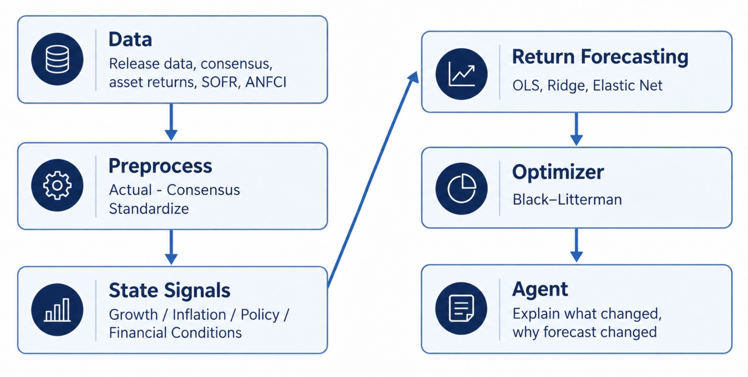
2. Where each model is used

3.1 Model Stack
Stage | Goal | Models / Methods to Consider | MVP
Signal Construction | Build Growth / Inflation states | Weighted Index, PCA, Dynamic Factor Model | Weighted Index
Return Forecasting | Predict next-1M returns for Equity, Treasury, Credit | OLS, Ridge, Elastic Net, VAR / SVAR / BVAR | OLS + Ridge
Portfolio Optimization | Convert expected returns into asset weights | Constrained MVO, Black–Litterman, Robust MVO, CVaR, Risk Parity | Black-Litterman
CIO Reasoning Agent | Explain forecasts and allocation decisions | LLM, RAG, Tool Calling | LLM
Why these models? Start simple and interpretable. A more complex model should be used only if it improves out-of-sample results.
Example. Equity Forecast
Month | Growth | Inflation | Policy | E[R Equity]
July | +0.20 | +0.35 | Hawkish | +0.3%
August | +0.75 | −0.45 | More dovish | +1.0%

4. CIO Reasoning Agent

4.1 Role
Role. The Agent does not forecast returns. It explains what changed, why forecasts changed, whether signals align, and what the allocation means.
Question | Input | Output
What changed? | Growth / Inflation / Policy / FC | State change summary
Why changed? | Underlying releases | Key drivers
What did model do? | Expected returns | Forecast interpretation
What does it mean? | Weights + risks | Decision support

Example. Agent Output
Growth surprises strengthened while inflation surprises softened. Payrolls and retail sales were above consensus, while CPI and Core CPI came in below consensus. The model therefore increased the 1-month expected Equity return from +0.3% to +1.0%. Signals are broadly aligned, and the optimizer recommends a moderate increase in Equity exposure.

5. Portfolio Construction
Asset | Current Wt. | Exp. Return | New Wt.
Equity | 45% | +1.00% | 52%
Treasury | 35% | +0.25% | 29%
IG Credit | 20% | +0.55% | 19%
Optimizer. Use Black-Litterman optimizer with long-only weights and turnover awareness.

6. Validation
Layer | How to test | Main metrics
Forecast | Walk-forward / expanding window | OOS R², RMSE, direction
Portfolio | Backtest vs. benchmarks | Sharpe, drawdown, turnover
Ablation | Add layers step by step | Incremental value
Model comparison. Historical Mean → Growth+Inflation → +Policy → +FC → +Interactions

7. MVP vs. Expansion
Component | MVP | Later
Signal | Weighted index | PCA / Factor
Forecast | OLS / Ridge | Bayesian / nonlinear
Portfolio | Long-only MVO | Robust / BL
Agent | Explain forecast | Event monitoring

